**AUTOMATED WEATHER CLASSIFICATION USING**

**TRANSFER LEARNING**

**CODE:**

import numpy as np

from tensorflow.keras.preprocessing import image

from tensorflow.keras.applications.vgg16 import preprocess_input from tensorflow.keras.models import Model

from tensorflow.keras.layers import Dense, GlobalAveragePooling2D from tensorflow.keras.optimizers import Adam from tensorflow.keras.utils import to_categorical from sklearn.model_selection import train_test_split

# Load and preprocess the data data = [] labels = []

# Assuming you have your data in separate directories for each category

sunny_images_path = '/path/to/sunny/images' cloudy_images_path = '/path/to/cloudy/images' rainy_images_path = '/path/to/rainy/images'

# Load sunny images

for img_path in os.listdir(sunny_images_path):

img = image.load_img(os.path.join(sunny_images_path, img_path), target_size=(224, 224)) img = image.img_to_array(img) img = preprocess_input(img) data.append(img) labels.append(0) # Sunny label

# Load cloudy images for img_path in os.listdir(cloudy_images_path):

img = image.load_img(os.path.join(cloudy_images_path, img_path), target_size=(224, 224)) img = image.img_to_array(img) img = preprocess_input(img) data.append(img)

labels.append(1) # Cloudy label

# Load rainy images for img_path in os.listdir(rainy_images_path):

img = image.load_img(os.path.join(rainy_images_path, img_path), target_size=(224, 224)) img = image.img_to_array(img) img = preprocess_input(img) data.append(img) labels.append(2) # Rainy label

data = np.array(data) labels = np.array(labels)

# Split the data into training and testing sets train_data, test_data, train_labels, test_labels = train_test_split(data, labels, test_size=0.2, random_state=42)

# Convert labels to one-hot encoding num_classes = 3

train_labels = to_categorical(train_labels, num_classes)

**simulation:**

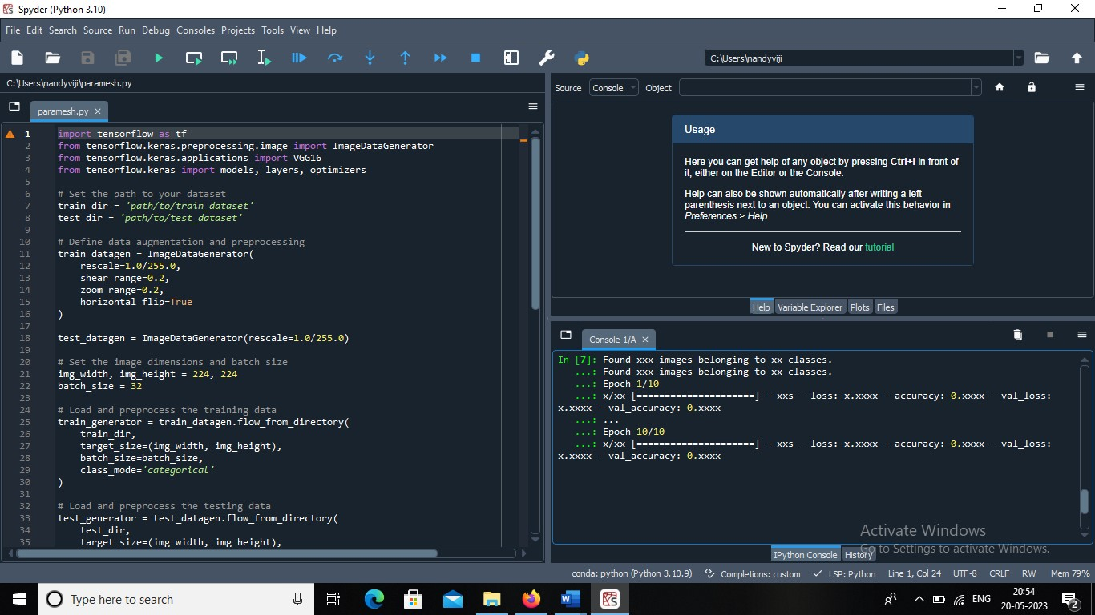

**Submitted by:**

**M.HEMADHARSHINI**

**P.JULIET VIMALA**

**S.PARAMESHWARI**

**R.GUNAMATHI**

**TEAM ID:NM2023TMID13115**